Media and Entertainment Industry
Software Requirements Document
V 1.0
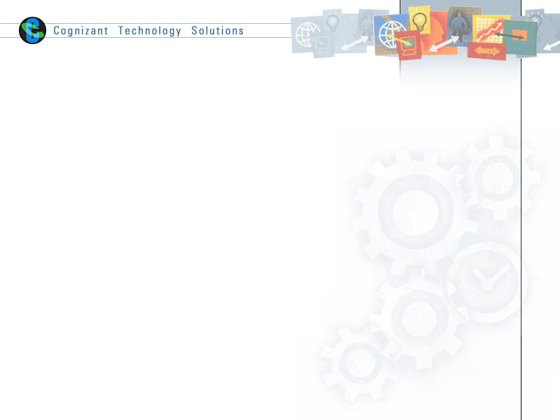

 | Prepared By | Reviewed by | Approved By
Name
Role
Signature
Date

Table of Contents
1 Introduction 4
1.1 About this document 4
1.1.1 Purpose & Scope of the document 4
1.1.2 Intended Audience 4
1.2 About the Software System 4
1.2.1 Scope of the system 4
1.2.2 Exclusions 5
1.2.3 System Perspective 5
1.2.4 System Environment 5
1.2.5 Architecture diagram 5
1.2.6 Impact of the System 6
2 System Requirements 6
2.1 Functional Requirements 6
2.1.1 Profit 6
2.1.2 Stock 6
2.1.3 Production 7
3 Annexure 7
4 Terms and conditions 8
5 Change Log 8

Introduction

About this document

Purpose & Scope of the document
The purpose of the software requirements document is to systematically capture requirements for the project and the system “Media and Entertainment Industry” to be developed. Functional requirements of this system are captured in this document. It also serves as the input for the project scoping.
The scope of this document is limited to addressing the requirements from a user, quality, and non-functional perspective. It is recommended that design aspects are not added in this document

Intended Audience
Project Team

About the Software System
The following section will cover aspects related to
We define the scope and objectives, and relate them to the requirements of Media and Entertainment. This is a good test case to see how a Data Warehouse can be built.

The following are the modules in this proposed system
- Profit
- Stock
- Production

Scope of the system
The scope of the system is explained through its modules as follows
- Profit– This module is to produce a report on Profitable store to increase its unit price per SKU. By analyzing the Sku’s sold each day and then coming up with a specific profit by department based on actual sku sales and costing. Dimension inventory fact which has the profit details.
- Stock – SKU produces the items and the price details which are there in the SKU Master dimension to produce the SKU items, prices and discounts.
- Production – This module is to find the Production of SKU’s based on Inventory Balance.SKU is an identification of a particular product that allows it to be tracked for inventory purposes. SKU Master is to get the information about the production details.

Exclusions
The system will operate only on the modules discussed above and will not include any additional functionality.

System Perspective
The system is a data warehouse developed to manage the activities like finding the Production of SKU’s, Profitable Movie Title, Profitable store per SKU.

System Environment

Architecture diagram

Physical Architecture:

Logical Architecture:

The Logical Architecture defines the Processes (the activities and functions) that are required to provide the required User Services. Many different Processes must work together and share information to provide a User Service. The Processes can be implemented via software, hardware, or firmware. The Logical Architecture is independent of technologies and implementations.

Stock
Stock

Data warehouse Layer

Source Layer
Production
Profit
Profit
Production

Impact of the System
The data warehousing system is being developed to enhance the decision support and generating customized reports for Media and Entertainment Industry.

System Requirements

2.1 Functional Requirements

Profit
                - DW – Profit
                - Req-2.1.1
Functional Requirements | - To find the profitable stores and generate the report to check whether the discount has to increase.  - This module is to produce a report on Profitable store to increase its unit price per SKU. By analyzing the Sku’s sold each day and then coming up with a specific profit by department based on actual sku sales and costing.  - Dimension inventory fact which has the profit details.

Stock

                - DW – Stock
                - Req-2.1.2
Functional Requirements | - To generate a report to find the most profitable movie title list in yearly basis.  - SKU produces the items and the price details which are there in the SKU Master dimension to produce the SKU items, prices and discounts.

Production
                - DW – Production
                - Req-2.1.3
Functional Requirements | - This is to produce the report by using inventory balance to get the forecasted production.  - To find the Production of SKU’s based on Inventory Balance. SKU is an identification of a particular product that allows it to be tracked for inventory purpose.  - SKU Master is to get the information about the production details.

Annexure

Terms and conditions
GenCs shall be solely responsible for all its acts and omissions under this program. GenCs will comply at all times with all applicable laws. GenCs shall not use Cognizant’s name, logo and trademark in any promotional materials or other communications with third parties without the prior written consent of Cognizant. Any materials used by GenCs in relation to program will not infringe the copyrights, trademarks, patents, trade secrets or other intellectual property rights, privacy or similar rights of any person or entity. GenCs agrees not to post, draw, make, display any content that is threatening, libelous, obscene, defamatory, abusive, pornographic, or advocates/encourages any conduct that could constitute a criminal offence or give rise to any civil liability. Cognizant its associates’ personal details including but not limited to name, address, contact number shall not be shared or forwarded to any third party, without prior written consent of Cognizant, its associates. All intellectual property provided by Cognizant as part of program shall be owned exclusively by Cognizant. Intern shall indemnify, defend and indemnify Cognizant its associates, officers, directors from and against any claims, demands, loss, damage, liability, causes of action, judgments, or costs and expenses of every nature (including attorney’s fees and expenses) incurred by Cognizant based on any claim that any breach of terms and conditions of this program.

Change Log
Please note that this table needs to be maintained even if a Configuration Management tool is used.
- Version Number | - Changes made
V1.0
V1.1 | <If the change details are not explicitly documented in the table below, reference should be provided here>
 | Page no | Changed by | Effective date | Changes effected
V1.2 | <If the change details are not explicitly documented in the table below, reference should be provided here>
 | Page no | Changed by | Effective date | Changes effected

